# UI Iteration

With the overall structure of the game determined, we found we needed to iterate our in-game HUD to handle the differences in data that playtesting encouraged. Our initial HUD below contained in some form all of our later systems:

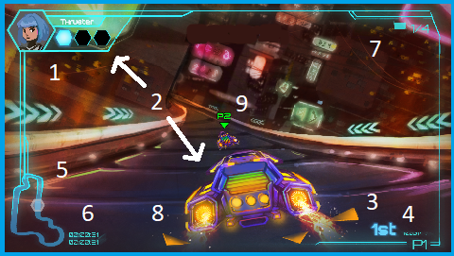

Figure : Old In Game UI Design

|  |  |  |
| --- | --- | --- |
| Number | Feature | Function |
| 1 | Player Avatar | Served to inform the player about the character they chose. Initially designed to animate when good or bad things happen. |
| 2 | Pickup amount and energy bar | Let the player know what pickup in the world they grabbed, how many they had, and how much energy they had to spend it (featured on the car itself). |
| 3 | Place | Served to let the player know what place they were in relevant to the rest of the racers. |
| 4 | Speed | Served to show how fast the player was going. |
| 5 | Minimap | Served to show where the player was in the race. |
| 6 | Time | Served to let the player know how well they were performing in the race, in terms of overall time. |
| 7 | Laps | Let the player know the overall progress of the race itself, in conjunction with the mini-map. |
| 8 | Proximity Indicators | Let a player know if another racer was nearby and behind them. |
| 9 | Player Icons | Let a player know what racer was in front of them. (Player 1, 2, etc.) |

Through significant playtesting and iterating, our final result proved dramatically different:

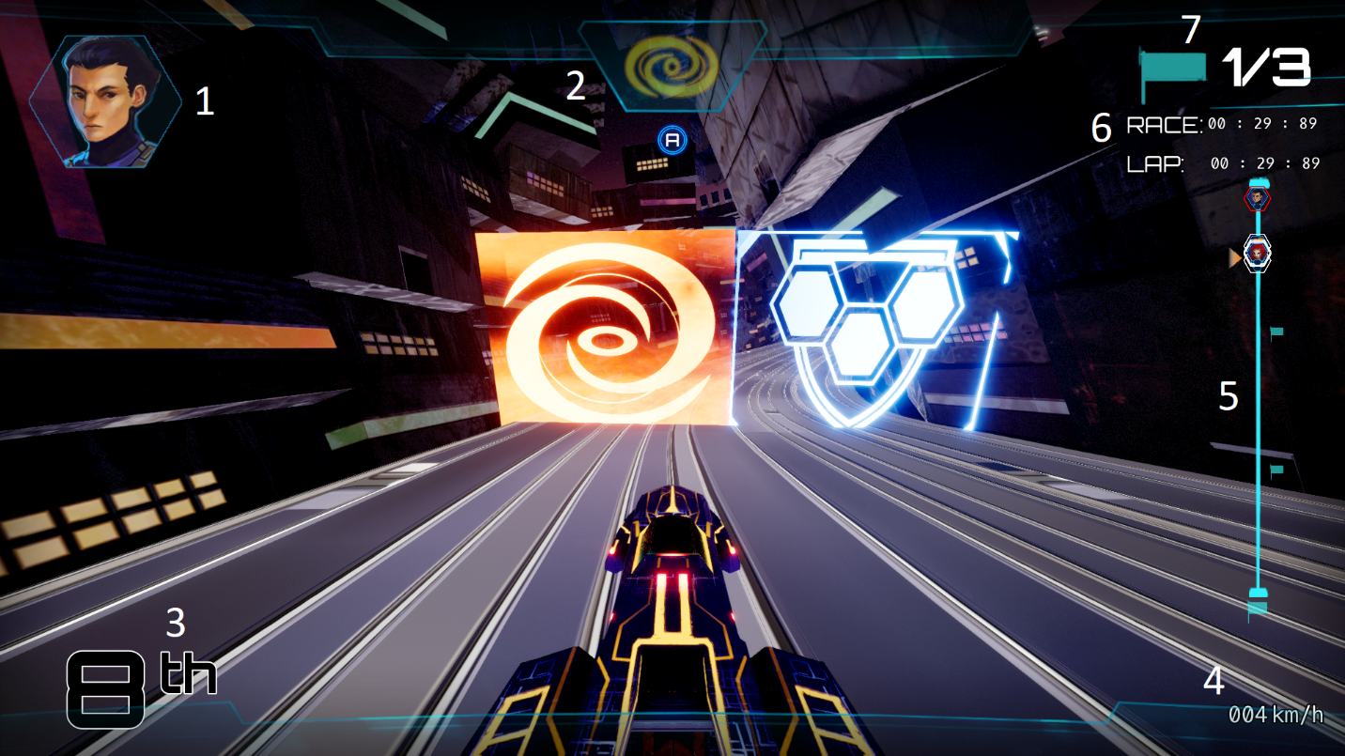

Figure : Main In Game UI Design

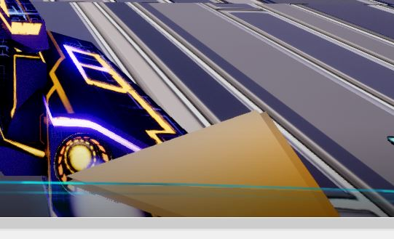 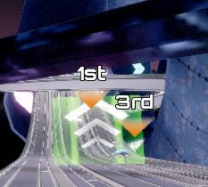 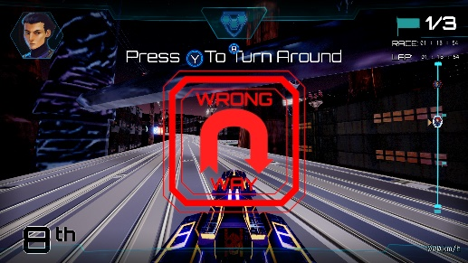

*Figure 3: [Left] 8. Proximity Indicators, [Middle] 9. Player Icons, [Right] 10. Turn-Around Sign*

|  |  |  |  |
| --- | --- | --- | --- |
| Number | Feature | Changes | Function |
| 1 | Character Box | We mostly kept the player avatar intact, save we removed the animation component and kept the avatar only in 1st player. | This feature serves to inform the player about the character they chose |
| 2 | Pickup amount and energy bar | We significantly overhauled our pickup energy system to instead give the player a power-up when they drove through an energy gate. This simplified gameplay, and felt more natural. | This feature lets the player know what pickup in the world they collect, and how to activate it. |
| 3 | Place | We received feedback that the place feature was too easily missed, so we pumped up the size and color of our place numbers, with first being Red, second being Green, and down the line. | This feature serves to let the player know what place they are in relevant to the rest of the racers. |
| 4 | Speed | We added and removed the speedometer several times throughout our iterative process. In the end, we ended up keeping this feature as players found that knowing how fast they were going was satisfying once we nailed down the racing mechanics themselves. Additionally we shortened the notified speed to under 1000 mph, to better match the overall apparent speed of the car in motion. | This feature serves to show how fast the player is going. |
| 5 | Minimap | The mini-map was reduced to a progress bar, as the overall 3-Dimensional complexity of the map and high speed of the car itself, made any information from a more complex mini-map take too long to understand. In response, we took the most useful piece of the mini-map thus far (race progress) and designed the mini-map around this idea as simply as possible. | This feature serves to show where the player was in the race. |
| 6 | Time | We received feedback that our Overall Race time and single Lap time were too difficult to see during the course of a race. Through significant iteration, we ended up modifying the size of the font, made the information more prominent in the player’s field of view, and clarified which timer is which to better aid in player communication. | This feature served to let the player know how well they were performing in the race, in terms of overall time. |
| 7 | Laps | Our laps feature remained mostly the same, with the exception that we increased the overall size, and modified the total number of laps to 3 as a standard. | This feature let the player know the overall progress of the race itself, in Our laps feature remained mostly the same, with the exception that we increased the overall size, and modified the total number of laps to 3 as a standard, in conjunction with the mini-map. |
| 8 | Proximity Indicators | We modified the overall size of the proximity indicators to make them more visible, but otherwise kept them the same. | This feature let a player know if another racer was nearby and behind them. |
| 9 | Player Icons | Due to player and stakeholder feedback, we found that modifying the data of the player icons to reflect place rather than player, made for a more enjoyable racing experience. Players were able to see that 3rd and 4th place were just ahead, and this felt more important than which players those were. | This feature lets a player know what racer is in front of them in terms of place. (1st, 2nd, 3rd). This icon is set to only appear when a player is somewhat near the racer. (So that you don’t see the icons at all times during the race). |
| 10 | Turn-Around Sign | As players played our game, it became more clear that due to the speed of our cars, and the narrowness of our tracks, we needed to let the player both know that they were going the wrong direction, but also add a mechanic to flip back around. We achieved this with a blinking sign, and mapping this feature to our Y button. | This feature lets a player know if they are going the wrong direction, and how to flip back around to quickly rejoin the race. |

In addition to these changes, one major change we made was in relation to the Player Viewport. We received feedback across the project that our early HUD was too loud and in the player’s way for a very fast game. In order to better manage this concern, we reduced the opacity, and better structured the border to accommodate the data in a way that made the data noticeable, while staying out of the race.  
  
Our early vision of the overall design of our UI/UX systems and how they integrated with the project, aided dramatically in our ability to iterate and improve these systems as the project wore on.